

SOPAN-Jal Nigam

(Application Architecture
Low Level Design Document)



M.P. STATE ELECTRONICS DEVELOPMENT CORPORATION LTD.
State IT Centre, 47-A, Arera Hills, Bhopal-462011 (M.P.)
www.mpsedc.mp.gov.in

Version | Date | Description | Prepared By | Reviewed By
1.0 | 01-03-2025 | First baseline version | Development | PM
1.1 | 19-05-2025 | Process view section added | Development | PM

Project Jal Rekha

Document APPLICATION DESIGN DOCUMENT

Document Name | Application Design Document
User Requirement Specification (URS) Document Version No. | 1.0
Effective Date

Author: | Reviewer: | Approver:
Leena | Tapan Khandelwal | Dr. Rakesh Dubey
Signature | Signature | Signature
Electronics copies valid without signature

Version Number | Submission Date | Nature of Modification
Version 1.0 | 19/05/2025 | Base document

Index
Contents
SOPAN (Madhya Pradesh Jal Nigam Maryadit) 1
1. Introduction 4
2. Objective 4
3. Authentication Process 6
4. Business RuleEngine 6
4.1. RuleProcessor 7
5. Database Components 8
6. ActionTemplate 9
7. Code Structure 10
8. DATA DESIGN 11
8.1. Database Architecture Diagram 11
9. NETWORK DESIGN 11
9.1. Network Architecture Diagram 11

Introduction

The Sopan module has been developed to streamline the process of capturing and monitoring contractors' commitments to the timely construction of overhead tanks (OHTs,WTP,Intake,IPS). Recognizing that delays and lingering by contractors were affecting project timelines, the department introduced this module to bring accountability, improve planning, and strengthen monitoring of construction works. The contractor selects the OHTs,WTP,Intake,IPS from the dropdown, chooses the type of Pre-Cast or Conventional and enters the planned start date and planned completion date. The General Manager can review the details, enters the actual start date and actual completion date, upload documents,approved, or add remarks if additional clarity is needed. The system will maintain a log of the communication between the GM and the contractor.

Objective

To improve accountability and timely completion of OHTs,WTP,Intake,IPS construction by recording contractor commitments, enabling GM review and communication, and ensuring effective monitoring of project progress.

2.1. Architecture Design and Components

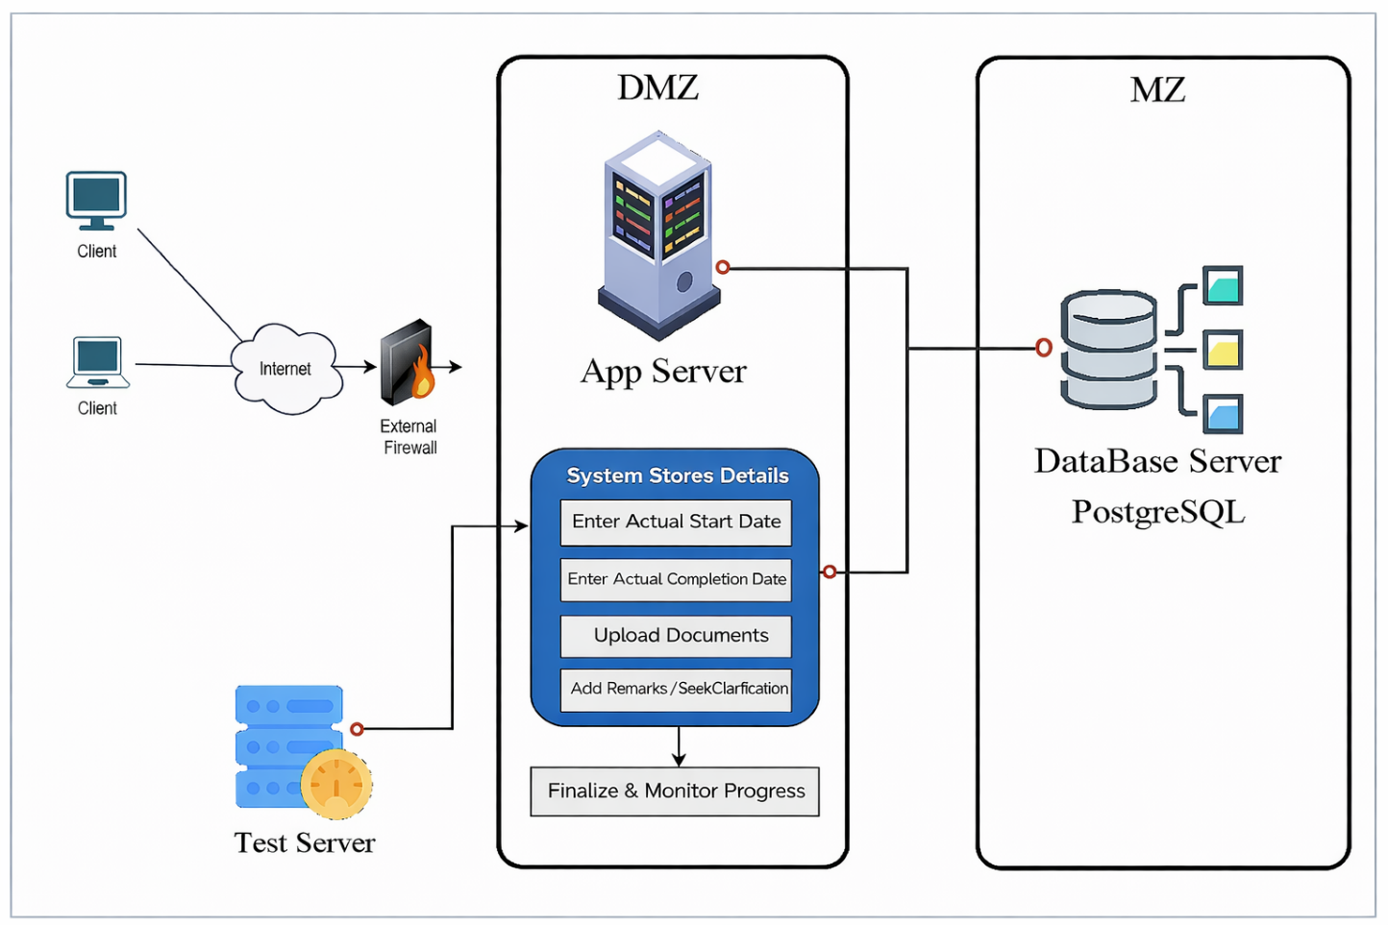

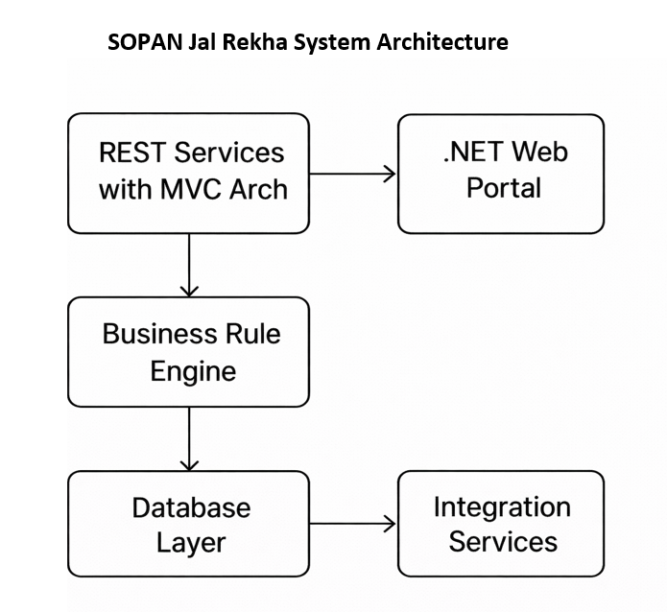

Web Portal (.NET-Based Front End)
- The SOPAN - Jal Rekha Web Portal is developed on the .NET framework, designed for department officials, administrators, and higher authorities.
- It enables planning, monitoring, approvals, and progress tracking.
- Authorized users can manage user roles, approve, generate drill down reports through the portal.

REST Services with MVC Architecture
- SOPAN (Jal Rekha) follows a decoupled RESTful architecture, the web portal interacts independently.
- The MVC structure ensures modular development and simplifies testing, maintenance, and future scalability.
- .NET web portal communicates with these REST services after successful authentication.
- Token-based authorization is implemented at the application level to secure data exchange and user operations.

Business Rule Engine (BRE)
- The Business Rule Engine governs all workflows, validations, and approval processes within SOPAN Jal Rekha.
- All rules, roles, and privileges are defined at the database level, ensuring centralized control over system operations.
- User permissions are dynamically assigned based on their roles, enabling controlled access to modules like planning, monitoring, approvals, and drill down reporting.

Database Layer
- The database layer securely manages all datasets required across the SOPAN Jal Rekha platform, including Planning status, approvals, reporting and scheme information.
- Data is stored using Object Relational Mapping (ORM) techniques for seamless integration between applications and the database.
- The database is synchronized between the primary server and integrated application services to ensure real-time data availability.
- Role-based access controls and privileges are also maintained at the database level to secure user operations.

2.2. Data Flow Diagram

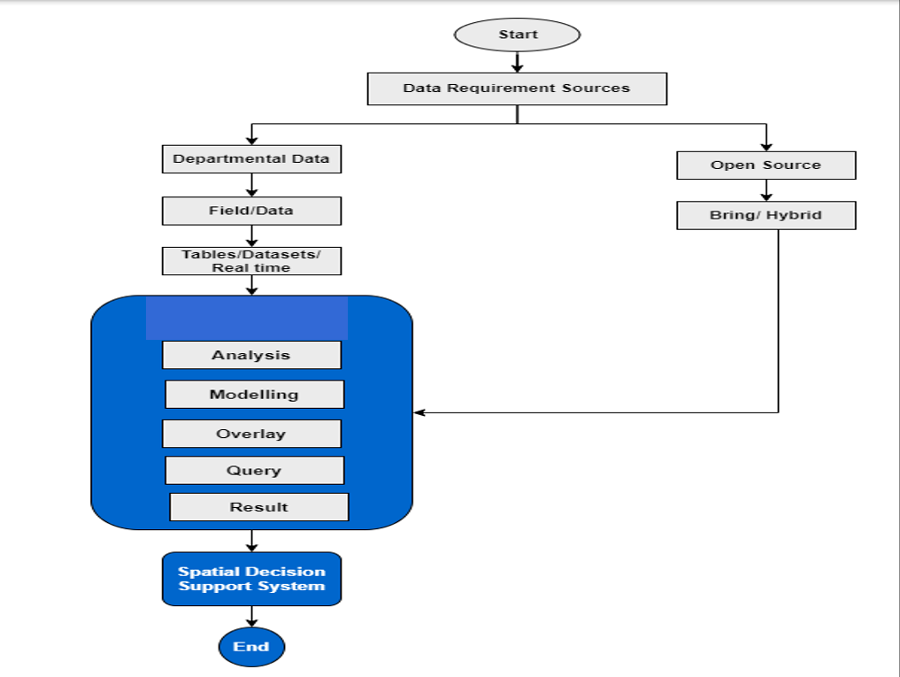

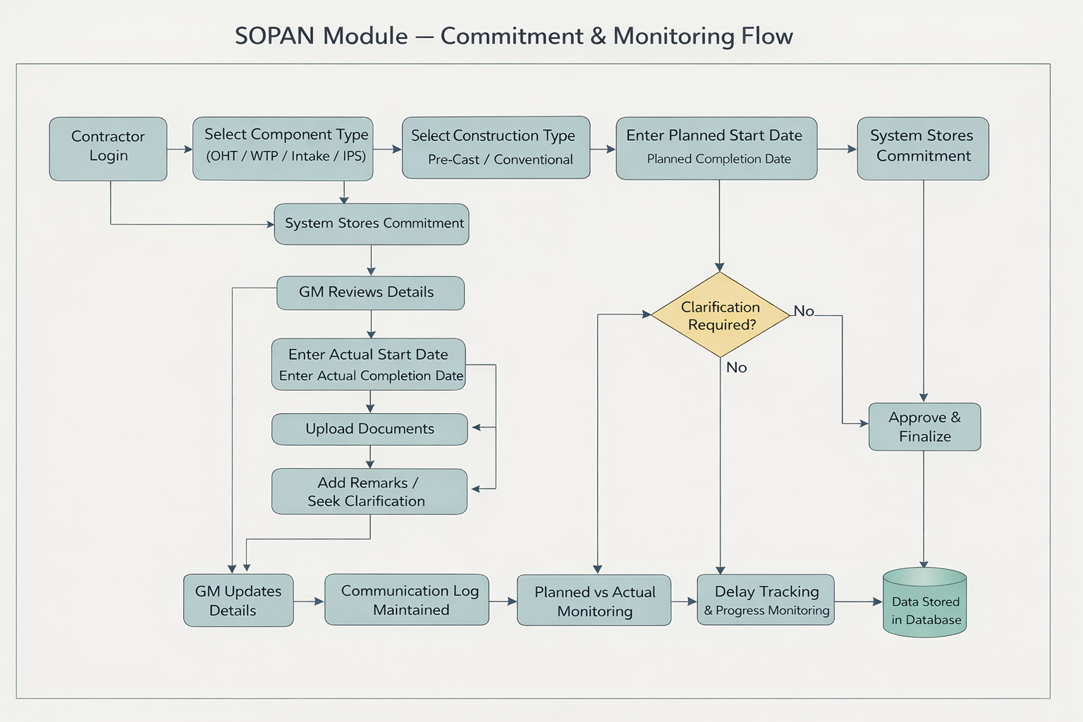

Client Side
- The SOPAN Jal Rekha Web Portal is developed on .NET Framework and serves as the primary platform for department officials, administrators, and higher authorities to manage workflows and drill down reporting.
- Both Android and .NET front ends communicate with RESTful APIs through a secure channel.

Architecture Principle
- Each component in the mobile application depends only on the layer directly below it, ensuring loose coupling and maintainability.
  - Activities and Fragments → depend only on the View Model.
  - View Model → depends on the Repository layer.
  - Repository Layer → connects to both persistent data models (local database) and remote backend services.
- The Repository acts as a single source of truth and manages data synchronization between the local database and remote API services.

Service Layer
- The Service Layer acts as the bridge between the client side and the server side, handling API communications.
- Sends and receives multiple API requests such as:
  - User login & authentication
  - Data submission & updates
  - Work of components are scheduled by contractor
  - GM Approval process for contractor work
  - Report generation & progress monitoring
- Services ensure real-time data exchange between field users, the server, and the SOPAN Jal Rekha database.

Server Side
The server-side architecture of SOPAN Jal Rekha is based on .NET MVC principles and consists of Presentation Layer, Application Layer, Domain Layer, and Data Layer.

1. Presentation Layer (Controller Layer)
- The Controller handles requests from the front end (Web Portal).
- It sends commands or queries to the Application Layer.
- Controllers validate inputs, initiate business processes, and return structured responses to clients.

2. Application Layer
- Manages the application services and orchestrates workflows.
- Responsible for executing service requests using:
  - Domain Entities (business models)
  - Repositories (data access and persistence)
  - Integration Agents (for external services)
- Implements all business rules, validations, and authorization checks.

3. Domain Layer
- Domain Entities are model classes representing database tables and mapping data between the database and the API.
- Repository Base (abstract class) and IRepository Base (interface) are implemented to provide a generic repository pattern:
  - Reusable CRUD operations for all entities.
  - Entity-specific repositories inherit from the Repository Base.
  - Allows creating custom interfaces for entity-specific operations while keeping common logic centralized.

4. Data Layer
- The Data Layer manages:
  - Repositories → provide data access through a generic repository pattern.
  - Mapping → binds database models to table fields and handles request/response translation.
  - Database Context → maintains database connections and session handling.

SOPAN Process Flow

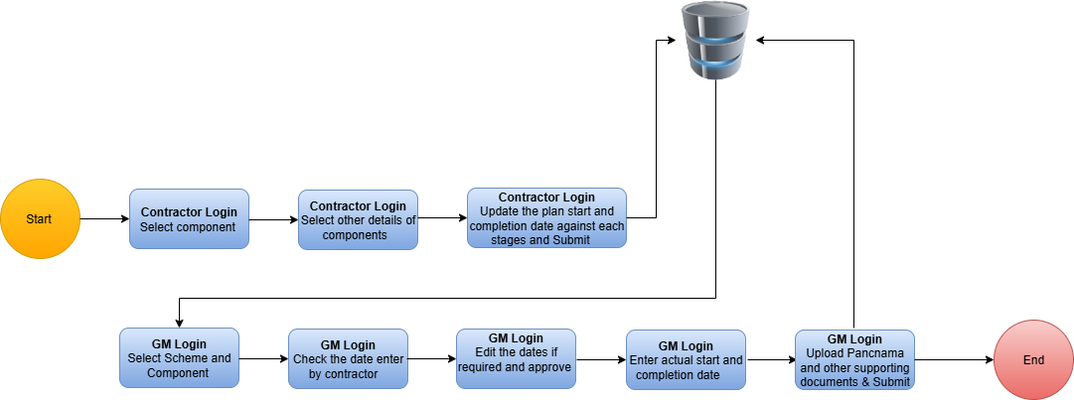

SOPAN Module Flow
1. Contractor
- Select Type from dropdown
(OHT / WTP / Intake / IPS)
- Select Construction Type
(Pre-Cast / Conventional)
- Enter:
  - Planned Start Date
  - Planned Completion Date
- Submit commitment details

2. System
- Stores contractor commitment

3. General Manager (GM) Review
- View contractor-submitted details
- Verify timelines
- Enter:
  - Actual Start Date
  - Actual Completion Date
- Upload supporting documents (if required)
- Add remarks / seek clarification (if needed)

4. Communication & Clarification Loop
- Contractor responds to GM remarks (if any)
- GM reviews updated information
- System maintains:
  - Complete communication log
  - Change history of dates and remarks

5. Monitoring & Tracking
- Compare:
  - Planned vs Actual dates
- Track delays and progress
- Enable effective monitoring by department

6. Data Storage & Reporting
- All data stored securely in database
- Enables:
  - Progress drill down reports
  - Delay analysis
  - Accountability tracking

Business Rule Engine

The Business Rules define the workflows, validations, roles, privileges, and data handling policies for the SOPAN Jal Rekha system. These rules ensure data integrity, controlled access, and smooth coordination between field engineers, contractors, department officials, and administrators.

1. User Roles and Privileges
The system follows role-based access control (RBAC) to manage permissions:
Role | Responsibilities | Access Level
Contractor | Submit planned date, upload documents, insert Remark | Restricted access
General Manager | upload documents, add remarks, enters/ update actual date and | Read-Write access
Business Rule:
- Each user must be authenticated using a unique ID and secure token before accessing the system.
- Users can only access modules and data assigned to their role.

2. Planning Rules
- Components include OHTs, intake wells, Intake and IPS.
- Contractor can add planning date and remark.
- GM can add /update actual date and update planned date Once.
- GM can approve plannings of contractor.
- Mandatory attributes:
  - Scheme ID
  - Type of component
  - Component
- Business Rule:
  - No record can be saved without planned date.
  - Duplicate asset entries are not allowed.

3. Planned Workflow Rules
Workflow:
Contractor → General Manager (GM) Approval
Business Rules:
Contractors: -
1) OHT Work plan start, plan end date against each stage and Submit
2) Intake work plan starts, plan end date against each stage and Submit
3) WTP work plan start, plan end date against each stage and Submit
4) IPS work plan start, plan end date against each stage and Submit

General Manager
1) Check all Scheme & component details, Freeze Actual plan date & fill actual work start and end date OHT
2) Check all Scheme & component details, Freeze Actual plan date & fill actual work start and end date WTP
3) Check all Scheme & component details, Freeze Actual plan date & fill actual work start and end date Intake
4) Check all Scheme & component details, Freeze Actual plan date & fill actual work start and end date IPS

Sopan Document Upload & Chat
1) Upload Panchama and other supporting documents & Submit
2) Chat functionality with Contractor

All Web User
1) OHT - Mapping, Monitoring, & Report
2) WTP - Mapping, Monitoring, & Report
3) Intake - Mapping, Monitoring, & Report

4. Data Collection and Validation Rules
- Contractor must collect and upload:
  - Component details (WTP, OHT, Intake wells)
  - Documents
- Business Rules:
  - The system validates mandatory fields before allowing data submission.
  - In case of missing or invalid data, the system will flag the entry for review.

5. Work Progress Monitoring Rules
- Work progress will be tracked scheme-wise and component-wise.
- Contractors must regularly update progress through the app.
- Department users can monitor work using the drill down reports.
- Business Rule:
  - GM can update planned date once.

6. Security and Authorization Rules
- The system uses token-based authentication for all API calls.
- User credentials are encrypted before storage and transmission.
- Unauthorized access attempts are logged and reported automatically.

Business Rule:
  - Each API request must include a valid authorization token.
  - Session timeout will occur after 15 minutes of inactivity.

7. Reporting Rules
- Drill down Reports are generated for:
  - Scheme-wise status
  - Planning dates approvals and rejections
- Business Rule:
  - Only department users and administrators can generate consolidated reports.
  - Contractors/GM can access their own reports but no other contractors’/GM’s data.

8. Caching and Performance Rules
- Frequently accessed datasets like master data, component types, and user roles are cached for better performance.
- Business Rule:
  - Cache refresh happens every 24 hours or on-demand when updates are made.
  - If cached data conflicts with the database, the database version always overrides.

Rule Processor

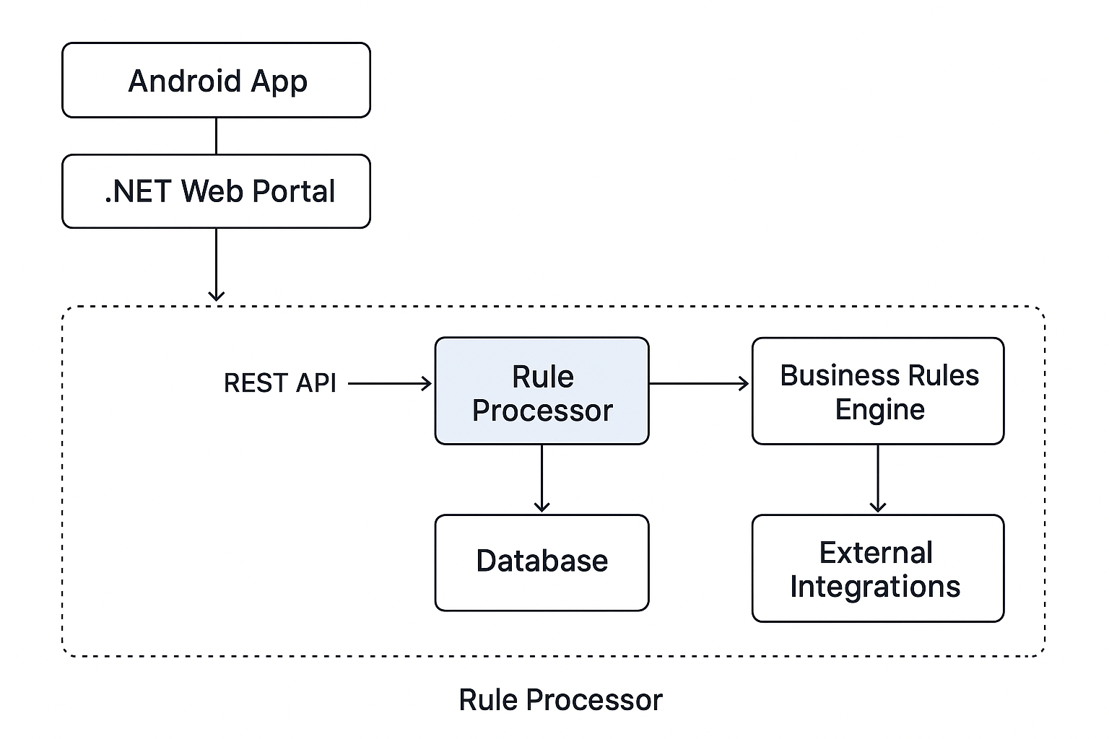
The Rule Processor in SOPAN Jal Rekha is the core component responsible for executing, validating, and managing business rules defined within the system.
It ensures that every workflow, inspection, component update, and approval process follows predefined policies, user roles, and access privileges.

1. Purpose of the Rule Processor
- To ensure consistency in workflows and validations.
- To automate decision-making based on predefined rules.
- To control access permissions based on user roles and privileges.
- To ensure data accuracy and prevent unauthorized updates.

2. Rule Execution Flow
The Rule Processor works as a middleware layer between the Application Layer and Database Layer.
When any request is made (e.g., planning update, component approval, progress submission), the following flow occurs:

Step 1 – Request Triggered
- A user initiates an action from either:
  - .NET Web Portal

Step 2 – Rule Invocation
- The Rule Processor fetches the relevant business rules based on:
  - Module (Planning, Approval, Progress Monitoring, Reporting etc.)
  - User Role (Contractor, GM)
  - Workflow Stage (Pending, Approved, Rejected)

Step 3 – Rule Validation
- Validates:
  - User authentication & authorization
  - Mandatory field completion
  - Duplication checks
  - Documents validations
  - Approval hierarchy checks

Step 4 – Decision Making
- If the request meets all defined rules, the processor allows the operation and passes it to the database layer.
- If the request fails any validation, it is rejected with an appropriate error message.

3. Types of Rules Managed by the Rule Processor

Rule Type | Description | Example
Access Rules | Defines who can access which module or data. | A contractor cannot updates planning dates.
Workflow Rules | Enforces process sequences and approval hierarchies. | Planning must be entered before approval.
Data Validation Rules | Ensures correctness and completeness of data. | GM have to authority to verify planned dated.
Security Rules | Handles authentication and authorization. | API calls must have a valid security token.

4. Key Features of the Rule Processor
- Dynamic Rule Management → Rules can be added or modified without affecting core code.
- Role-Based Decision Making → Permissions are applied automatically based on the user role.
- Workflow Automation → Reduces manual intervention by automating repetitive tasks.
- Centralized Rule Definition → All business rules are defined in a single logical engine.
- Audit and Logging → Every rule executed is logged for tracking, monitoring, and debugging.

5. Rule Processor Integration in Jal Rekha
- Android App & .NET Web Portal → Initiate requests.
- RESTful Services → Pass requests to the Rule Processor.
- Rule Processor → Validates, enforces workflows, and applies business rules.
- Database Layer → Stores processed and validated data.

6. Example Scenarios

Scenario 1 – Planning Approval Workflow
- Contractor adds planning dates.
- Rule Processor checks:
  - Is the contractor authorized for this scheme?
  - Are documents uploaded?
- Planning is sent to the General Manager for approval.
- If invalid → GM rejects the request and notifies the contractor.

7. Benefits of the Rule Processor
- Ensures standardized workflows across SOPAN Jal Rekha.
- Enhances security with strict role-based control.
- Improves data quality and avoids duplication.
- Automates decision-making and reduces manual delays.
- Makes the system scalable by allowing easy rule updates.

Database Components

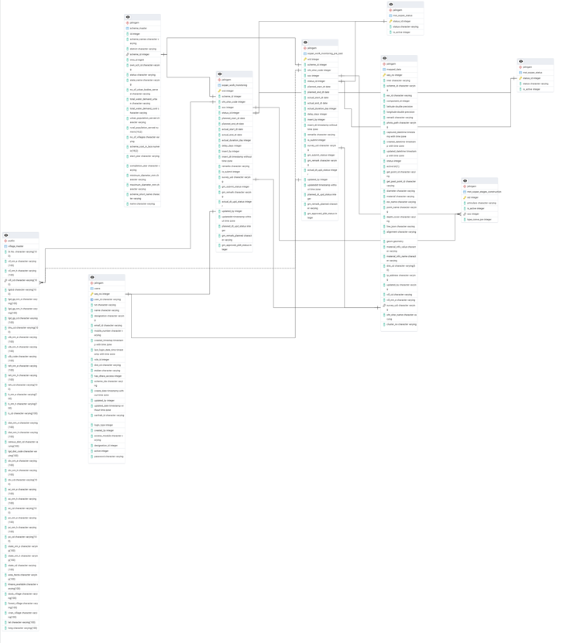

Action Template

Code Structure

DATA DESIGN

Database Architecture Diagram

The SOPAN Jal Rekha System will implement data replication in a distributed environment to ensure high availability, scalability, and data security. Replication will improve system performance by maintaining multiple synchronized copies of the database across different servers.

The Master Database will handle both read and write operations.

Slave Databases will be used only for read operations to optimize performance and reduce the load on the master server.

In case of high traffic, read requests will be distributed among slave databases, ensuring faster response times.

The system will also maintain a Disaster Recovery (DR) Server where one of the slave databases will continuously synchronize data in real time. This ensures business continuity and prevents data loss in case of any server failure or unexpected downtime.

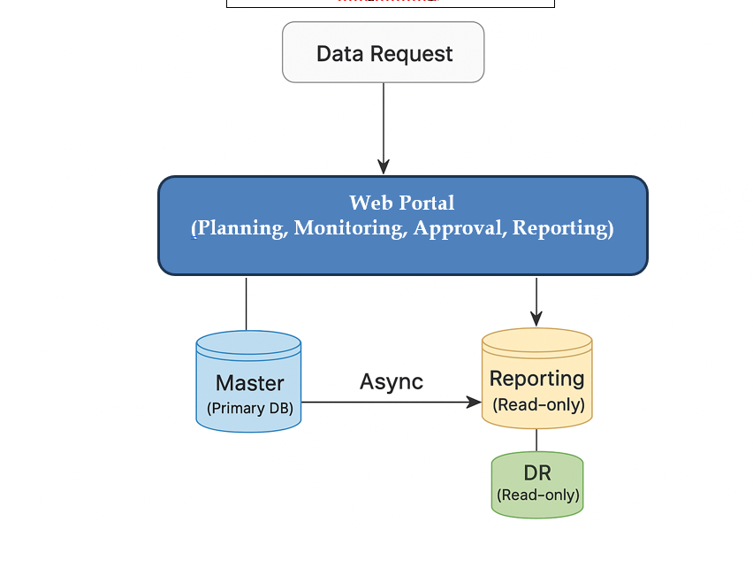

NETWORK DESIGN

Network Architecture Diagram

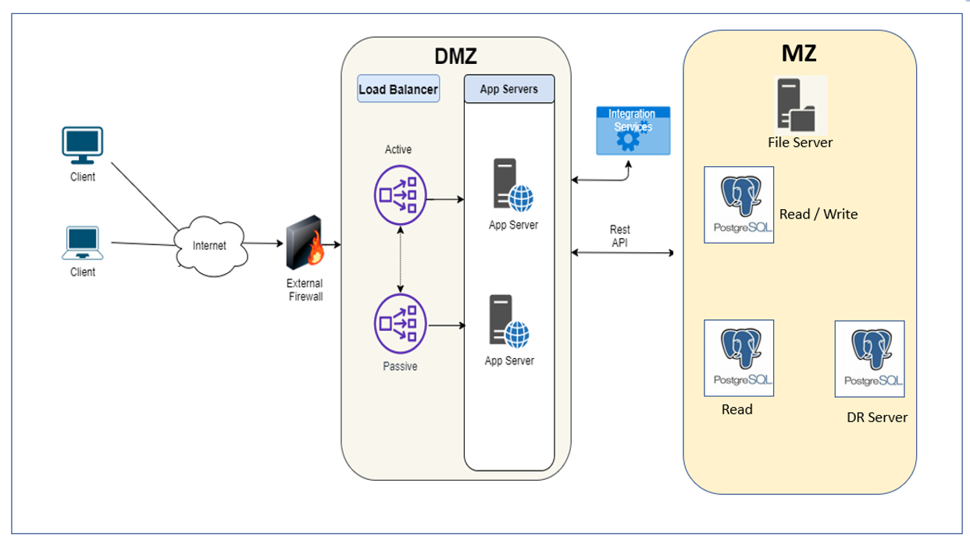

The SOPAN Jal Rekha system has been designed with a highly secure, scalable, and fault-tolerant network architecture to ensure seamless service delivery for both web clients. The architecture consists of three major layers:

1. Client Layer
This layer represents all types of users accessing the SOPAN Jal Rekha platform:
- Web Clients – Access the .NET-based portal for project management, monitoring, and reporting.
- API Consumers – External systems or integration partners interacting through secure REST APIs.
All client requests are routed over HTTPS to ensure secure data transmission.

2. DMZ Layer (Demilitarized Zone)
The DMZ acts as a secure buffer zone between the external network and the internal system. It ensures that external users interact with application servers without exposing internal resources.

Key Components in DMZ:
- External Firewall
Protects the internal infrastructure by filtering unauthorized traffic and allowing only secure HTTPS requests.
- Load Balancer
  - Distributes client requests between multiple App Servers for better performance.
  - Supports Active-Passive Failover to ensure high availability.
- Application Servers (.NET-based)
  - Hosts the Jal Rekha web portal and REST APIs.
  - Manages business logic, API processing, and user authentication.
  - Handles Android and web requests in a unified way.

3. MZ Layer (Main Zone / Data Layer)
This layer stores, processes, and manages SOPAN Jal Rekha’s data.

Key Components:
- File Server
Stores uploaded documents, reports, images, and geospatial data securely.
- Master Database (PostgreSQL – Read/Write)
  - Centralized database for handling all read/write operations.
  - Stores service requests, project data, user information, and reports.
- Slave Database (PostgreSQL – Read-Only)
  - Optimized for reporting and analytics.
  - Offloads read-heavy queries from the master database to improve performance.
- Disaster Recovery (DR) Server
  - Maintains a real-time replicated copy of the master database.
  - Ensures data continuity in case of unexpected failures or downtime.

4. Security Features
- HTTPS Everywhere – All communications are encrypted using SSL/TLS.
- Role-Based Access Control (RBAC) – Ensures that users only access permitted data and services.
- Database Security – Uses real-time replication with secure authentication and encryption.
- API Security – All REST APIs require token-based authentication and are protected behind firewalls.

5. High Availability & Replication
- The Load Balancer ensures uninterrupted access even if one server goes down.
- Master-Slave Replication keeps a synchronized copy of data for reporting.
- The DR Server ensures zero data loss during system failures or natural disasters.
- The system can auto-promote a slave database as a master in case of hardware failure.

